Chang’an University 2024－2025 The 2nd semester （ A ）
Course | Hydraulic and Pneumatic Transmission |  |  | Date |  | / / |  | 19 questions
Name |  | School |  |  | Class |  | ID
I Fill in the blanks. (20 points, 1 point for each blank)
- The working pressures in the hydraulic system depend on . The speed of the actuating element depends on .
- The viscosity of the oil is highly sensitive to temperature. When the temperature of the oil rises, its viscosity will .
- The hydraulic system is mainly composed of five parts. Among them, the component that converts pressure energy into mechanical energy is element. The component that control and regulate the pressure, flow rate and flow direction of the oil is element.
- According to Reynolds test, the main states of fluid flow are and in a pipe.
- Hydraulic pumps can be classified by the forms of main moving components and their moving manners: , , and screw pumps, etc.
- The common pressure operated valves include , , and pressure relay.
- The speed stiffness of the speed-regulating valve is high. The speed-regulating valve is composed of two valves connected in series. They are and .
- According to the different installation positions of the throttle valve in the circuit, the throttle speed-regulating circuit is divided into , and .
- Sequence action circuits allow several actuator motions to obey the setting scheduled actions in turn. There are two kinds of control methods: and .
II Short answer question items. (20 points, 5 points for each)
- What are the advantages of hydraulic transmission?
- What is the displacement of hydraulic motor? Please explain the volumetric efficiency and mechanical efficiency of hydraulic motor?
- As shown in the figure below, this is the characteristic curve of the pressure-limited variable pump. Please briefly explain the reasons for the changes in flow rate of AB section and BC section with the variation of pressure?
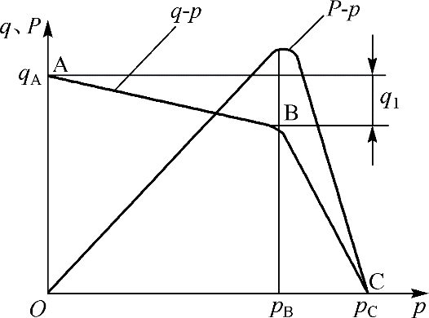

第 1 页(共 4 页)
- Please write out the differences between pilot operated relief valves and pilot operated pressure reducing valves.

III Calculations. (30 points, 10 points for each)
- There is a water storage device as shown in the figure. The water storage tank is large enough. When the valve is closed, the reading of the pressure gauge is 2.8 atmospheric pressure. While when the valve is fully opened and water flows out from the pipe, the reading of the pressure gauge is 0.6 atmospheric pressure. Please calculate the flow rate through the outlet when the pipe diameter d = 12 cm (ignoring flow losses, assuming 1 atmospheric pressure is 1×10⁵ Pa and the gravitational acceleration g is 10 m/s²)
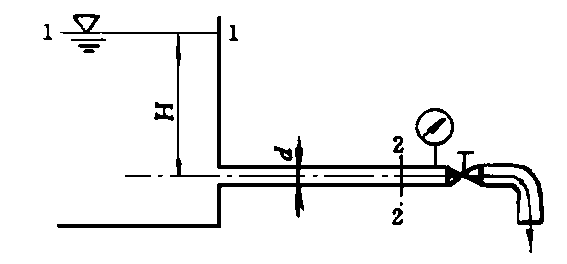

- The inlet pressure of a hydraulic motor is 10MPa, the displacement is 200mL/r, the total efficiency is 0.75, and the mechanical efficiency is 0.9.
(1) The theoretical torque that the motor can output.
(2) If the speed of the motor is 500r/min, what is the flow rate of the infusion motor?
(3) If the external load is 200 N∙m (n= 500r/min), what is the output power and input power of the motor?

- As shown in the figure, the setting pressure of the relief valve of the system is 5MPa, and the setting pressure of the pressure reducing valve is 2.5MPa. Try to analyze the following conditions, and explain the pressure reducing valve port in what state?
(1) When the outlet pressure of the hydraulic pump is equal to the set pressure of the relief valve, how much is the pressure at point A and C after the clamping cylinder makes the workpiece clamp?
(2) When the outlet pressure of the hydraulic pump is reduced to 1.5MPa due to the fast forward of the working cylinder (the workpiece is originally in the clamping state), how much is the pressure at point A and C?
(3) When the clamping cylinder makes no-load movement before clamping the workpiece, what is the pressure of point A, B and C?

第 2 页(共 4 页)
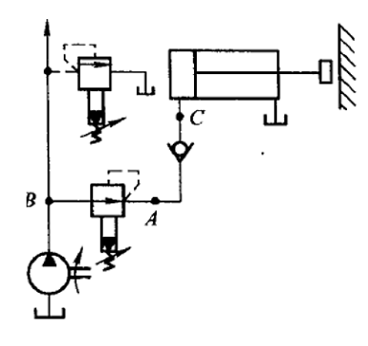
IV Diagramming question. (15 points)
1. Please write the name of basic hydraulic circuits and hydraulic components (10 points).
(1) | (2)
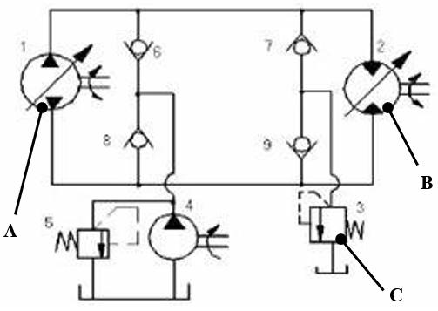 | 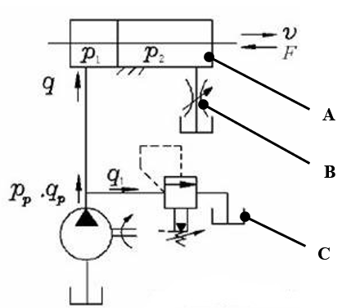

Hydraulic basic circuit |  |  | Hydraulic basic circuit
Component A |  |  | Component A
Component B |  |  | Component B
Component C |  |  | Component C
2. Please draw the symbol diagram of the following components. (5 points).
(1) Three-position four-way manual directional control valve | (2) Hydraulic-operated check valve | (3) Speed-regulating valve
(4)Pilot-operated pressure-reducing valve | (5) Internal control external discharged sequence valve

第 3 页(共 4 页)
V Analysis. (15 Points)
Based on the hydraulic system diagram, answer the following questions.
(1) The hydraulic system can achieve functions such as rapid feed, working feed, hold, Quick retract and stop. Please complete the solenoid action sequence table. (“+” indicates “energized”, “—” indicates “no energized”) (5 points)
(2) When the system performs the rapid feed, what is the flow path of the oil in the circuit? What is the name of the basic circuit used? (5 points)
(3) When the system performs the working feed, what is the flow path of the oil in the circuit? What is the name of the basic circuit used? (5 points)

Solenoid Working States
Solenoid Working States | 1YA | 2YA | 3YA
Rapid feed
Working feed
Hold | + | － | －
Quick retract
Stop | － | － | －
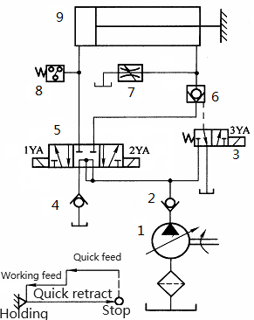

第 4 页(共 4 页)

